Practical conservation projects throughout south east Essex Spring 2017

THE
SOUTH EAST ESSEX
CONSERVATION VOLUNTEERS

(TCV Community Network)

The State of Nature: Some Aspects

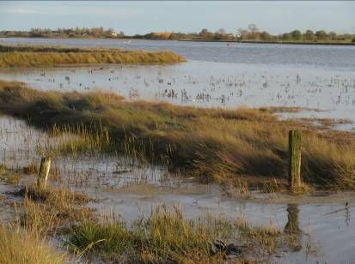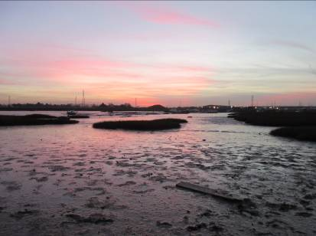
River Roach (Stambridge) – will the turtle doves visit this summer?

In the 1960s as a young birdwatcher in Suffolk I was pleased to send my report of a dozen singing lesser whitethroats, in six parishes in my local area, to the county bird recorder. His retort was that in his younger days he would expect to find at least that number in a single parish. This is an example of the ‘shifting baseline syndrome’, a term first used by American marine biologists in connection with the management of fish stocks – i.e. you may think the baseline, or natural state, of a stock is what it was at the start of your career, but it actually may once have been very much greater. Succeeding generations are unaware of what has gone.

In recent decades, however, in contrast to the 1960s, we have garnered objective evidence of declines in many species. For example, the British Trust for Ornithology’s Common Birds Census revealed that in a period of only 25 years we lost millions of birds from our countryside, the worst losses being concentrated in the period 1970 – 1980. The State of Nature report 2016, to which 53 wildlife organisations contributed, revealed that more than one in ten UK species is threatened with extinction and 56% of UK species are in decline. 75% of the UK is managed for food production, and 20% of all impact on species populations was due to ‘intensive management of agricultural land’. Farmland birds have declined by 54% since 1970, and butterflies by 41% since 1976.

One of the worst declines has been in the turtle dove, a summer visitor with us between April and September. It has declined in the UK by 93% since 1970. When I began walking the Roach Valley Way in 2002 there were turtle doves along the whole route from Rochford to Paglesham Churchend. By 2007 there was a distinct decline, the last breeding occurred in 2013, in 2015 I saw only a single bird, and by 2016 the species had totally disappeared. Conservationists in the county have recently created ‘foraging plots’ for turtle doves in various localities, planted with a special seed mix of food plants, and it is hoped that such plots will be successful.

Farmers are supported by environmental stewardship schemes currently funded by the EU Common Agricultural Policy (CAP) and the UK government. The UK vote to leave the EU puts the future of those schemes at risk and it remains to be seen what assistance the UK government will give to farmers post-Brexit.

Alan Last


Many thanks to Rochford Parish Council who have made a donation of £200 in respect of our assistance at Doggetts Wildlife Area.

We’re celebrating! It’s our 30th anniversary!

Formed in 1987, the South East Essex Conservation Volunteers have been working regularly throughout the area ever since!

But as we care about the environment, we’ll only be releasing virtual balloons!!!

Happy New Year!

Wishing you a happy and healthy 2017

Practical conservation projects throughout south east Essex Spring 2017 Programme

The South East Essex Conservation Volunteers
(TCV Community Network)

All projects start at 10.00am at the designated meeting place. If you intend to arrive later, please arrange to meet on site. You are not required to stay all day, or even work all day! Don’t forget to bring some food and drink, to dress in old clothes and to wear stout footwear (preferably safety toe-caps). Please also bring work/gardening gloves. If you think you may have difficulties with directions, please phone Julian on 01702 258492.

N.B. Children under 16 years MUST be accompanied by a responsible parent/guardian.

January 8th - Dodd’s Grove (adjoining Belfairs Nature Reserve)
Meet at the end of Poors Lane South, Hadleigh.
Led by local wildlife expert Don Down, ground clearance will be carried out to encourage biodiversity.

January 22nd - St. Laurence Orchard, Eastwood (Trust Links / Southend Borough Council)
Meet on site. The Orchard is on the corner where St. Laurence Way meets Eastwoodbury Lane.
Hedgelaying. We are gradually laying the perimeter hawthorn hedge at this site (we complete a few metres each year!).

February 5th - Canewdon sites (Finches Nature Reserve / Lion Creek (EWT) / Lower Raypits (EWT))
Meet by the Anchor PH car park, High Street, Canewdon.

Winter maintenance jobs.

February 19th - Hadleigh Country Park (Essex County Council)
Meet by the rangers’ office at the far end of Chapel Lane, Hadleigh.
Project unconfirmed.
(Please note the rangers’ office is near the bike shop and their door says “Welcome, please pull door”)

New members welcome!
March 5th - Rayleigh Mount (National Trust)
Meet by the main entrance to the Mount in Bellingham Lane, near the Mill Hall.
Coppicing.

March 19th - Doggetts Wildlife Area, Rochford (Rochford Parish Council)
Meet at the far end of The Boulevard (follow up road adjacent to Waterman Primary School).
Potential work includes path/pond maintenance and general site improvement.

April 2nd - Hadleigh Country Park (Essex County Council)
Meet by the rangers’ office at the far end of Chapel Lane, Hadleigh.
Project unconfirmed.
(Please note the rangers’ office is near the bike shop and their door says “Welcome, please pull door”)

April 16th - Easter Sunday (No project planned)

April 30th - St. Mary’s Nature Reserve, North Shoebury (Southend Borough Council)
Meet in the car park of St. Mary’s church, North Shoebury Road, North Shoebury.
General maintenance required at this site (e.g. path clearance).
N.B. This may be a morning-only project.

For further details and joining information, please contact the South East Essex Conservation Volunteers:

SEECV, c/o Charnwood, Anchor Lane, Canewdon, Rochford, Essex, SS4 3PB

Tel: 01702 258492 (Julian)

Email: SEECV@abpayne.plus.com Website: http://www.seecv.org.uk/

